Software Requirements Specification For:

CVen7

Version 1.0

Prepared by Michael Levitin, Benel Aharon, Nastaran Motiee,

Re’em Levi, Ortal Bukra, Yarden Aliev Krief.

Group 7

20.11.17

Table of Contents

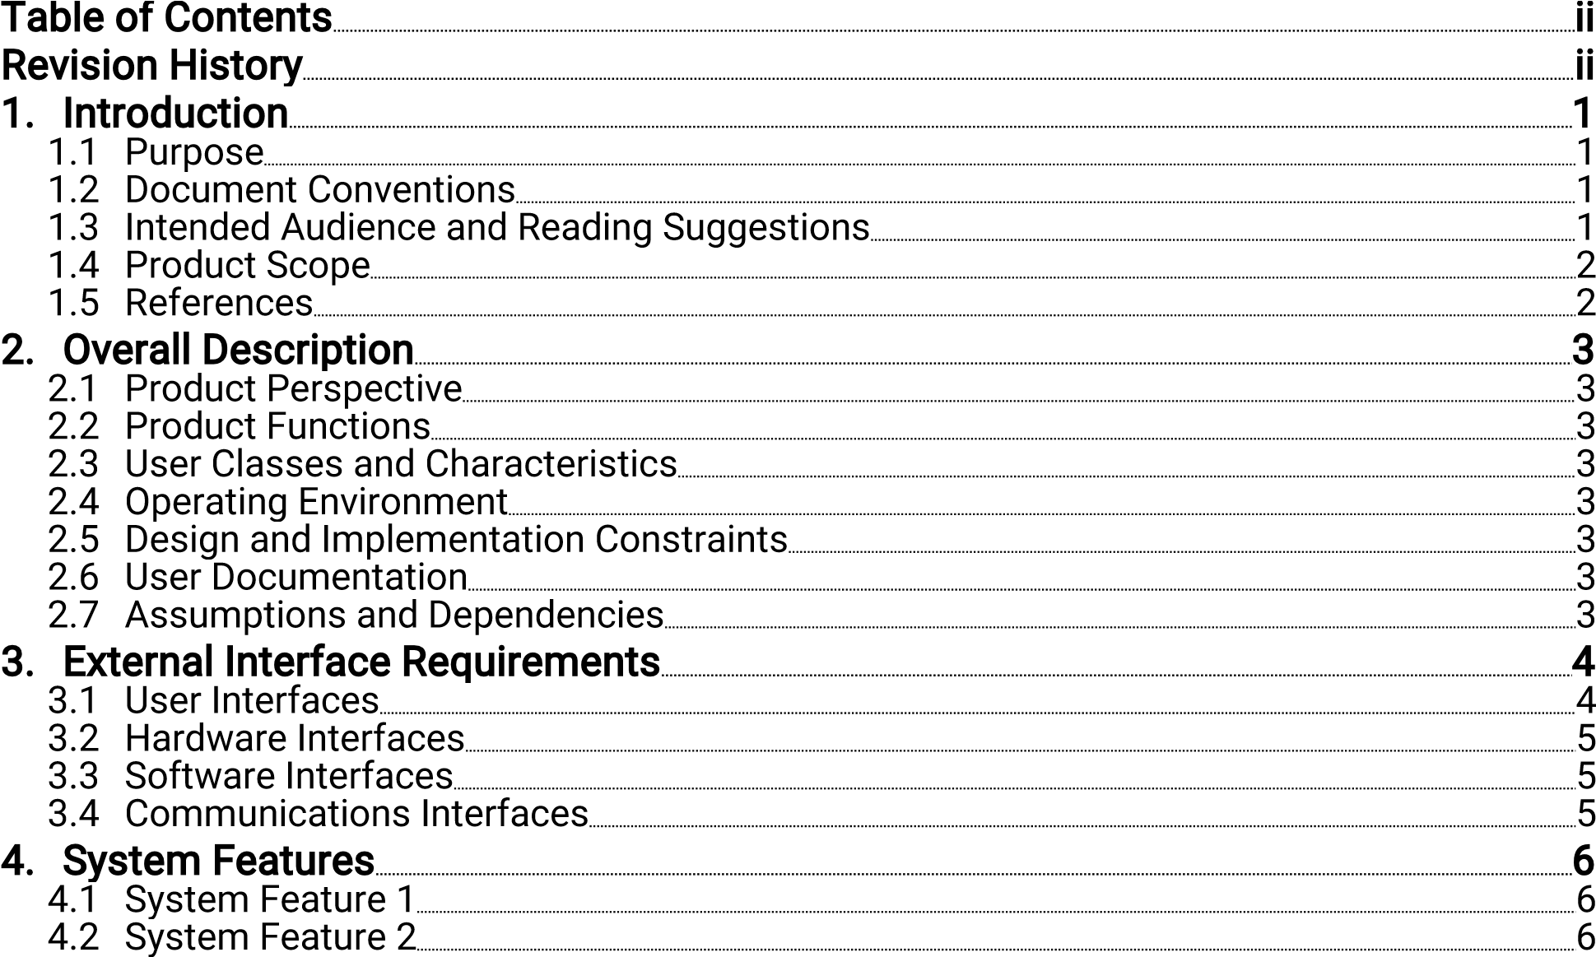

4.2 System Feature 3 ……………………………………………………………………………………………………………………….7

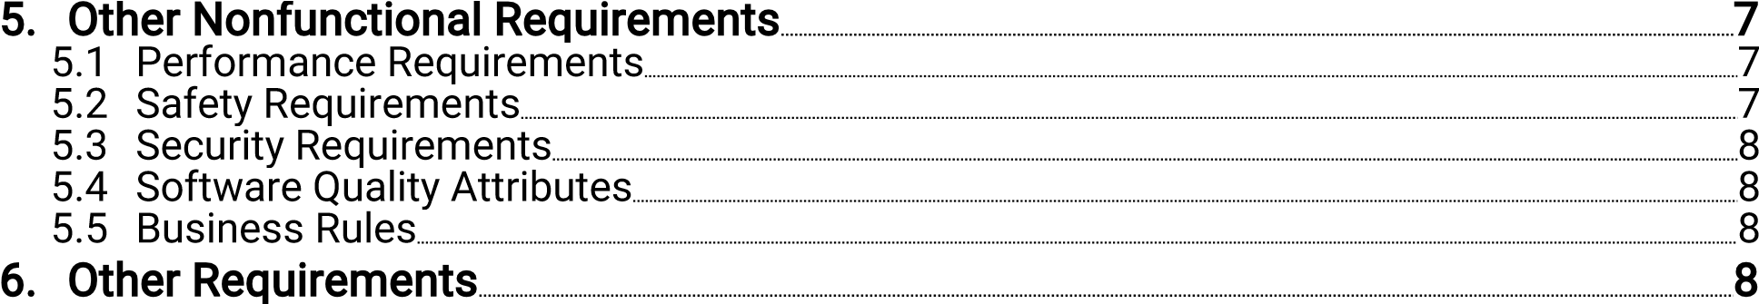

Revision History

|  |  |  |  |
| --- | --- | --- | --- |
| Name | Date | Reason For Changes | Version |
|  |  |  |  |
|  |  |  |  |

Introduction

Our client requested a new product for their HR department that will enable them to easily sort and review CV applications.

Requirements:

*GUI that allows possible candidates to apply and send the CV applications.

*The CV applications will be written and applied to the database digitally via the interface.

*Secured database protected by passwords and encryption only to be accessed by the HR department.

*HR department only GUI that allows to sort, note, rank and review the applications.

*Manager accesses to the database in order to submit the final status of the candidate.

*A request was made to allow different HR employees using a new function to review a specific candidate

1.1 Purpose

Creating an GUI that will allow the HR department the possibility to sort, review and easily manage candidates CV applications.

1.2 Document Conventions

|  |  |
| --- | --- |
| Term | Definition |
| HR | Human resources |
| GUI | General user interface |
| CV | Curriculum vitae |
| User | HR department or candidate |
| OS | Operating system |
| Candidate | Possible new employee - CV applicator |

1.3 Intended Audience and Reading Suggestions

The SRS document intended for the following:

Programing department

Project manager

The clients HR department – In order the review the prototype

1.4 Product Scope

The product purpose is to create a database for HR departments and firms that will manage the CV applications sent to them via a user interface.

The product traits:

Easily sort different CV application by the area of expertise.

As well the option to rate and sort different candidates by the following traits:

*Personal summary

*Academic history

*Skills

*Career history *References

1.5 References SRS template:

https://web.cs.dal.ca/~hawkey/3130/srs_template-ieee.doc Author: Karl E. Wiegers, 1999

Login window: https://www.google.co.il/search?biw=1707&bih=806&tbm=isch&sa=1&ei=t

r0SWp_WOM_EwAK4j4q4AQ&q=login+window&oq=login+window&gs_l=ps y-ab.3..0i67k1j0l8.359.359.0.655.1.1.0.0.0.0.212.212.2-

1.1.0....0...1.1.64.psy-

ab..0.1.212....0.4y5R_OsuphU#imgrc=ir5PNazA5pCO2M:

CV examples:

https://www.google.co.il/search?q=cv+example+template&source=lnms&t bm=isch&sa=X&ved=0ahUKEwiwsOnk1szXAhXC2BoKHSrZAXMQ_AUICigB &biw=1707&bih=806#imgrc=qvDqPbq6u79AyM:

https://www.google.co.il/search?q=cv+example+template&source=lnms&t bm=isch&sa=X&ved=0ahUKEwiwsOnk1szXAhXC2BoKHSrZAXMQ_AUICigB &biw=1707&bih=806#imgrc=phyIRLA_Npqp_M:

1. Overall Descriptions
   1. Product Perspective

The product is a new self-contained GUI for a HR department. The product is intended to simplify and short the sorting process and finding the right candidate for the job.

After logging to the system via a password. The HR department will have the tools to search throw thousands of CV application by choosing the needed traits of the candidate like personal summary, academic history, skills and so on.

Those tools will help the HR department of finding the best candidate for the job and in the fastest way.

* 1. Product functions

*Logging in a secure data base using the clients account.

*Choosing which attributes you are interested in.

*Ranking the different candidates by the attributes.

*Editing the CV documents in order to add notes.

*Choosing the status of the candidate for the applied job (hired, rejected and so on).

* 1. User classes

Only the HR department will have access to the CV database and its functions and then transmitting it to other relevant bodies (manager for example).

* 1. Operating Environments

As of now the operating environment will be only Windows by Microsoft.

* 1. Design and Implementation constrains

Simple and easy to use visual interface operated by a mouse and keyword

* 1. User documentation

The product will come along with a user manual as well a one day training course that our manager will pass to the clients HR department.

* 1. Assumptions and Dependencies Operating only on a Windows OS.

The application of CV by a candidate will be require an internet connection. Access to the CV database will require a password.

1. External Interfaces Requirements
   1. User Interfaces

*General user - Initial logging screen

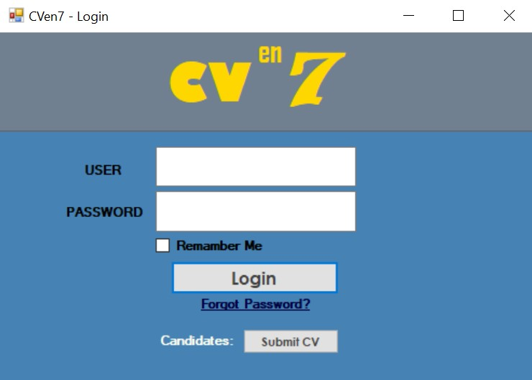

*HR - Database search windows

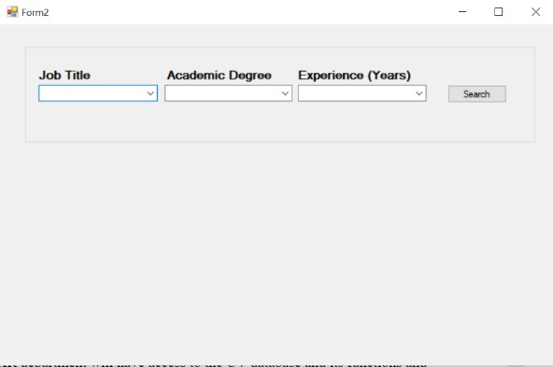

*HR - Data table

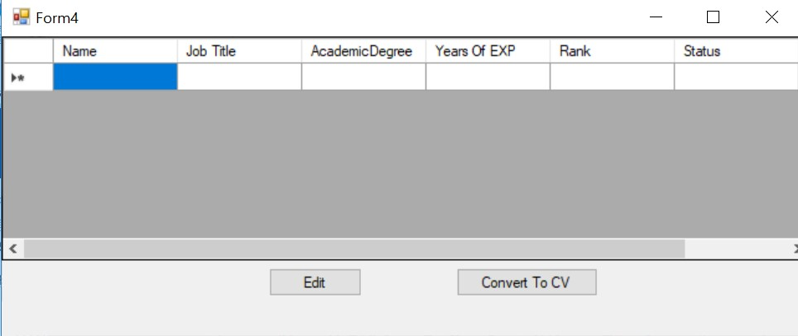

*Candidate - CV application window

* 1. Hardware Interfaces

*The software does not have any direct hardware interfaces. The hardware connection to the database server is managed by the operating system.

* 1. Software Interfaces

Windows OS on personal computers.

* 1. Communications Interfaces

The computer software will communicate with the database and vise versa via an encrypted and secured internet connection.

1. System Features
   1. Security feature
      1. Description and Priority

Logging windows that requires a password

* + 1. Stimulus/Response Sequence

Choosing the department.

Entering the password.

Clicking the “Login” button.

* + 1. Functional Requirements

Entering the right password only

* 1. Choosing attributes
     1. Description and Priority

A feature window that allows to chose the needed attributes.

4.2.2 Stimulus/Response Sequence

Using the computer keyboard or mouse to select the needed drop box and selecting the attribute

4.2.3 Functional Requirements Clicking the “Search” button

4.3 Choosing sphere

4.3.1 Description and Priority

A feature window that allows to chose the needed sphere.

4.3.2 Stimulus/Response Sequence

Using the computer keyboard or mouse to select the needed drop box and selecting the attribute

4.3.3 Functional Requirements Clicking the “Search” button

4.4 Ranking the candidates

4.4.1 Description and Priority

A feature that allows the user to rank the candidates by an internal algorithm based on the needs of the HR department

4.4.2 Stimulus/Response Sequence

Featured automatically in the data base table

4.4.3 Functional Requirements

All of the relevant attributes in the CV should be available.

4.5 Adding notes

4.5.1 Description and Priority

The feature allows the HR department and other relevant bodies to add the decision making notes during the review process.

4.5.2 Stimulus/Response Sequence

When chossing the candidate in the data base table an option of editing will appear.

4.4.3 Functional Requirements

The user needs to have the needed permission.

1. Other Nonfunctional Requirements
   1. Performance Requirements

-The candidate will submit the CV only digitally using the user interface.

-The product (as of yet) is only supported with the Microsoft Windows platform.

-The search threw the data base is very fast

-Bugs and frizzing is minimized

* 1. Safety Requirements

-The candidates personal information will be private and encrypted.

* 1. Security Requirements

-The permission to access and review the data base should be private to the relevant department of the client.

-If the password will be entered 3 times incorrectly the user will be blocked and the user will have to contact the technical division of our firm.

* 1. Software Quality Attributes

Multi tooled and easy to digital CV forms for the candidate to apply. Cloud based updates of the database hourly.

* 1. Business rules

Database cannot be accessed, viewed, altered by anyone not related to the HR department or product manager.

6.Other Requirements

Future features will be added to simplify and extend the tools given to the client.